OLAP Queries
-- 1) Total transactions and total amount (global snapshot)
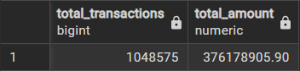
-- 2) Daily transaction volume & total amount (time series)
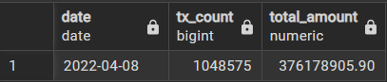
-- 3) Fraud rate by region (region-level risk)
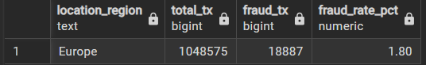
-- 4) Monthly fraud trend (year, month)
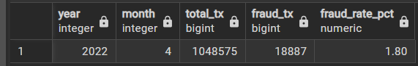
-- 5) Device type usage and fraud rate (device_type from dim_customer)
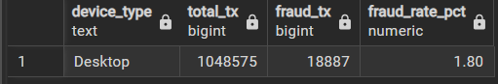
-- 6) Risk-category vs fraud rate (bucket risk_score from dim_behavior_risk)
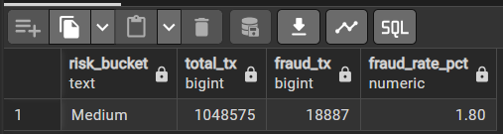

-- 7) High-value anomaly detection: transactions > mean + 3*stddev
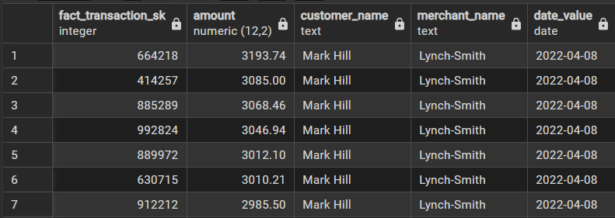
-- 8) Account flow summary: total inflow & outflow per account (aggregated)
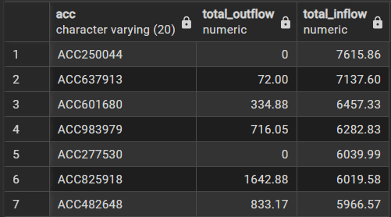
-- 9) CUBE example: merchant, region, month — amount and frauds for all combinations
